**Personal Finances**

**Project Objective**:

To create a personal finance accounting app to help users easily and conveniently track their income and expenses, and plan their budget for the future. The app should provide the ability to create "miscellaneous budgets", enter and view all financial transactions under a certain budget, and automatically sort and categorize them for the user's convenience. In addition, the app should have an intuitive interface that is accessible both, on a computer and a mobile device.

An example of what is meant by the phrase "miscellaneous budgets":

**Example 1**: I get 10,000 MDL in salary, no extra income. I live in such a way that I immediately divide my income by global areas, so that spending on:

1. household – 55% of income,
2. entertainment – 25% of income,
3. force majeure – 15% of income,
4. investments – 5% of income.

Each of the spheres includes categories of spending, i.e.: the sphere of life includes possible categories of spending: utilities, groceries, health, home, etc.

And I would be interested in an app that would allow me to keep track of how much money I have left under each sphere of life. To do this, I would create 4 different budgets with the above names. And each time I wanted to spend something, I would, when creating a transaction, specify which budget my spending relates to (household, entertainment, force majeure or investment), specify the spending value, the spending category within the budget, and after creating the transaction the corresponding value was reduced or added (depending on transaction type: spending or income), from the corresponding budget.

**Example 2**: I keep money in MDL, euros and dollars. And I would be interested in keeping track of how much money I have in my account separately in MDL, in euros and in dollars (without converting euros and dollars to MDL to see the overall status). To do this, I would create 3 budgets, where one of the currencies would be MDL, the other - euros, the third - dollars. And the transactions from these budgets would be respectively carried out in MDL, in euros and in dollars.

**The functionality of the application**:

1. Creating a budget, specifying the currency of the budget.
2. Deleting/archiving a budget.
3. Editing a budget (budget state name or value, NOT budget currency).
4. Viewing the transaction history of a specific budget (by clicking on it).
5. Viewing the overall transaction history by budget with sorting by day and calculating cash flow within a day (i.e. when sorted by day, at the level with the date to indicate how much was spent that day and how much was received, if transactions were in different currencies - divide spending and income by those currencies).
6. Creating a Transaction in which you can specify the budget (to which the transaction will be credited), the subcategory (if the budget is Domestic, then the subcategory is Utility or Food, etc.), the spending/income value (i.e. subcategories are still divided into spending (- from budget) and income (+ to budget)), date, note to transaction, add a photo, recurrence of the payment (i.e. If the payment is recurring every month, you can select recurrence every month and the application will automatically create such a transaction every month from the first time such a payment is created).
7. Possibility to view archived budgets as well as (by clicking on this budget) to view the history of the budget's transaction.

**Possible Interface:**

There will be 3 main tabs in the interface:

1. budgets.
2. history
3. archived.

**Budgets** tab**:**

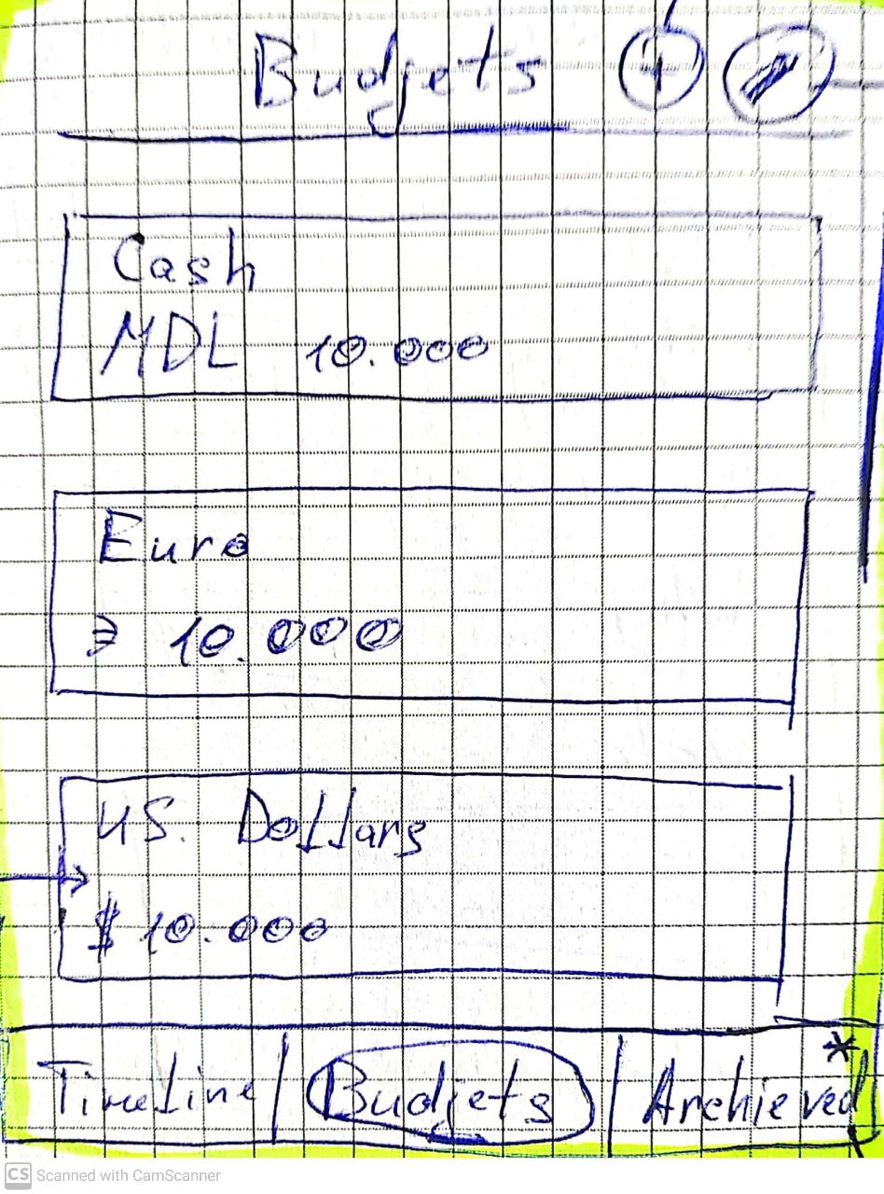

Name of the tab: Budgets

1. Below the budgets list in the form shown in the picture: Rectangle: first line - budget name, second line - currency and budget value (can be with a comma))

2. Next to the tab name, 2 buttons: plus and pencil.

3. The plus button brings up a form to create a new budget (Fig. 2.)

4. The pencil button turns on the mode when each budget has three buttons (Fig. 3): Delete, Edit, Archive. Clicking on the cross (appears instead of the pencil) exits this mode.

At the very bottom, there is a navigation menu on top of the elements and it consists of three main tabs.

Fig. 1. The budgets page **Plus Button**: Creates a new budget:

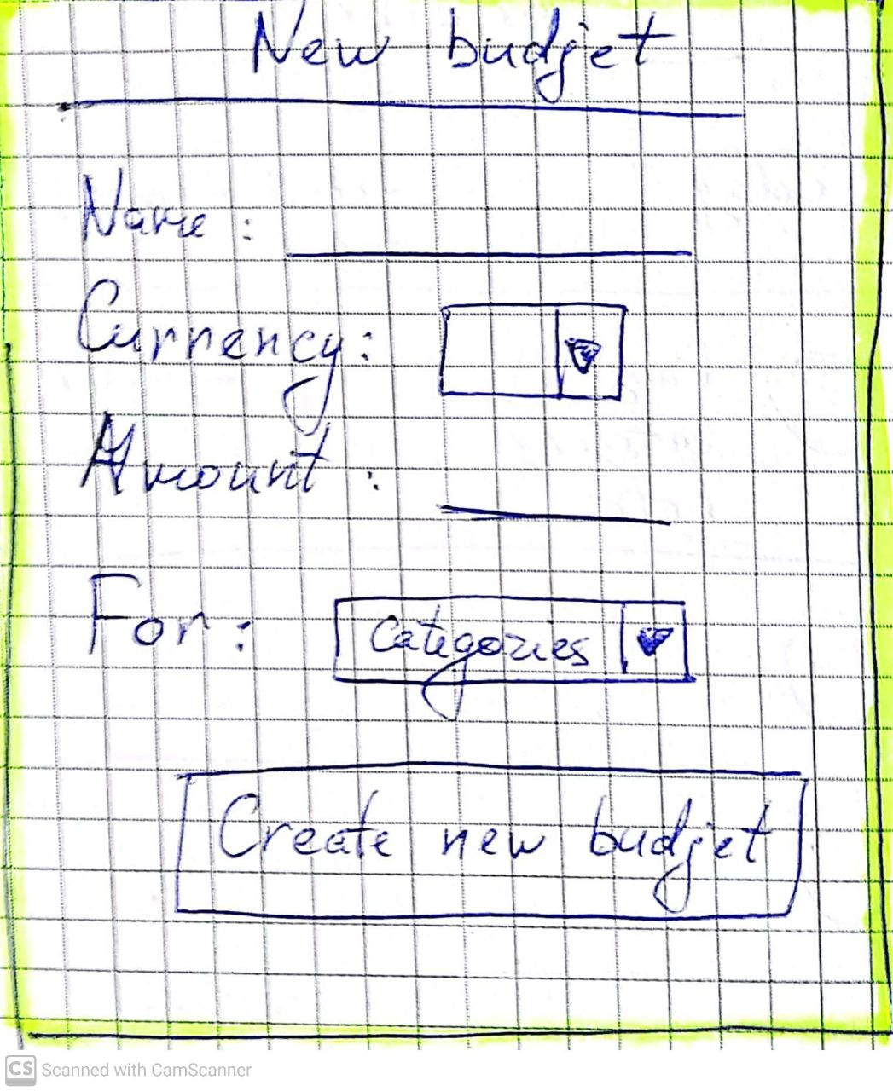

1. budget name.
2. Currency of the budget (choose from the standard set)
3. Budget value (can be with a comma)
4. For: list of possible categories (already available)
5. Create Budget button.

After clicking the Create Budget button, the new budget appears at the top of the list.

Fig 2: Creating a new budget

**Button Pencil**:

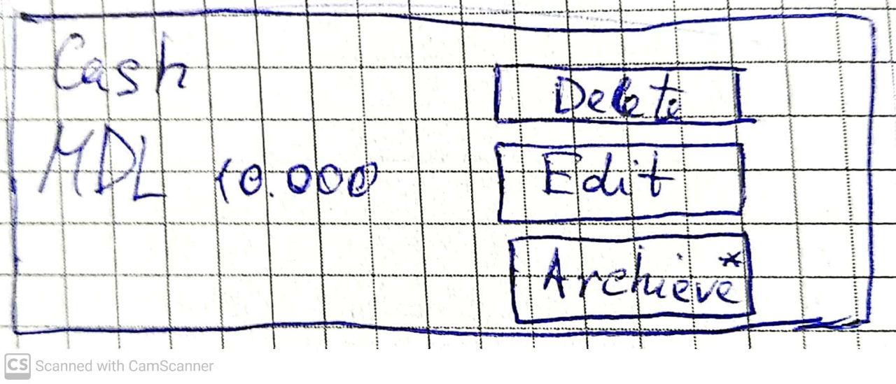

1. Delete budget
2. Edit Budget (a form similar to the budget creation form appears, where you cannot change the currency, you can add new categories).
   1. Archive. Moves the budget to the Archive tab. From there it cannot be restored or edited.

Fig 3. Pencil button.

Clicking on any budget area opens the history for that budget:

* + - 1. At the top the name of the budget.

1. Below, sort type (by day, week, month)
2. budget balance (as text in the highlighted rectangle)
3. Below is the history:
   1. 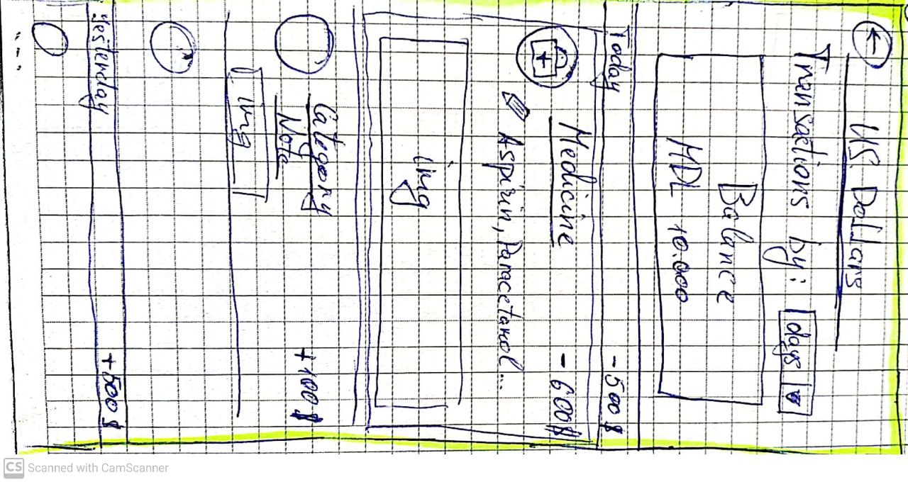First Day (today, yesterday, date), right total for the day (how much was spent, earned: counted based on transactions within the day)
   2. Then a list of transactions for that day:
      1. Each transaction is a rectangle with a category icon
      2. To the right of the Category by Text.
      3. Below the category note
      4. Below picture attached to the transaction
      5. In the right corner the value of the spend/income
   3. Below the next day
   4. etc.

If you click on a transaction, you can edit the spending value, and read the entire note.

By clicking on the picture, it opens in full format.

The Back Arrow button (next to the budget name), goes to the budgets page.

Fig 4. Clicking on a budget

**Archive** tab.

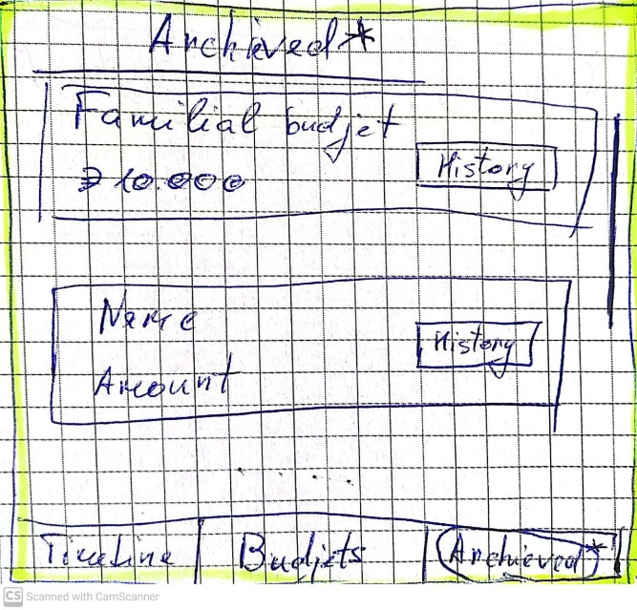Similar to the budgets tab, only in this tab the only thing you can do is to click the History button to view the transaction history for this budget. The history is similar to Fig. 4.

Fig. 5 Archive

**History** tab

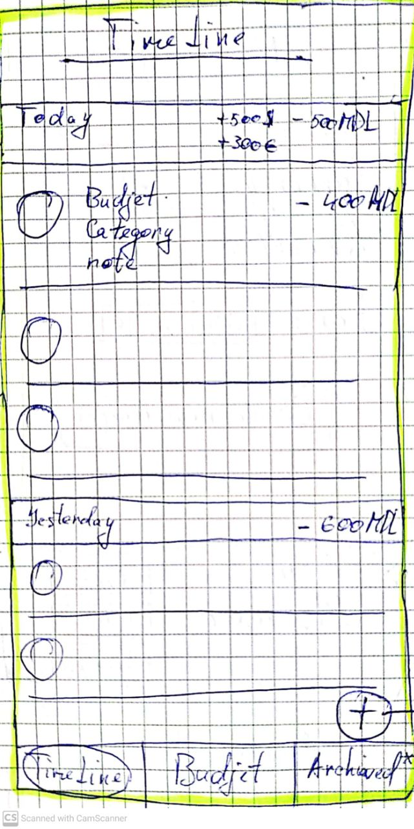Similar to the history inside the budget, except:

The budget to which the transaction is assigned is added to the transaction rectangle.

If within the day, there were transactions with different currencies, all transactions are added (between the same currency), and is displayed as on the picture (next to it)

In the lower left corner on top of transactions there is the button Plus, when you press it you will open the form of creating a transaction (Fig. 7)

Fig. 6 History

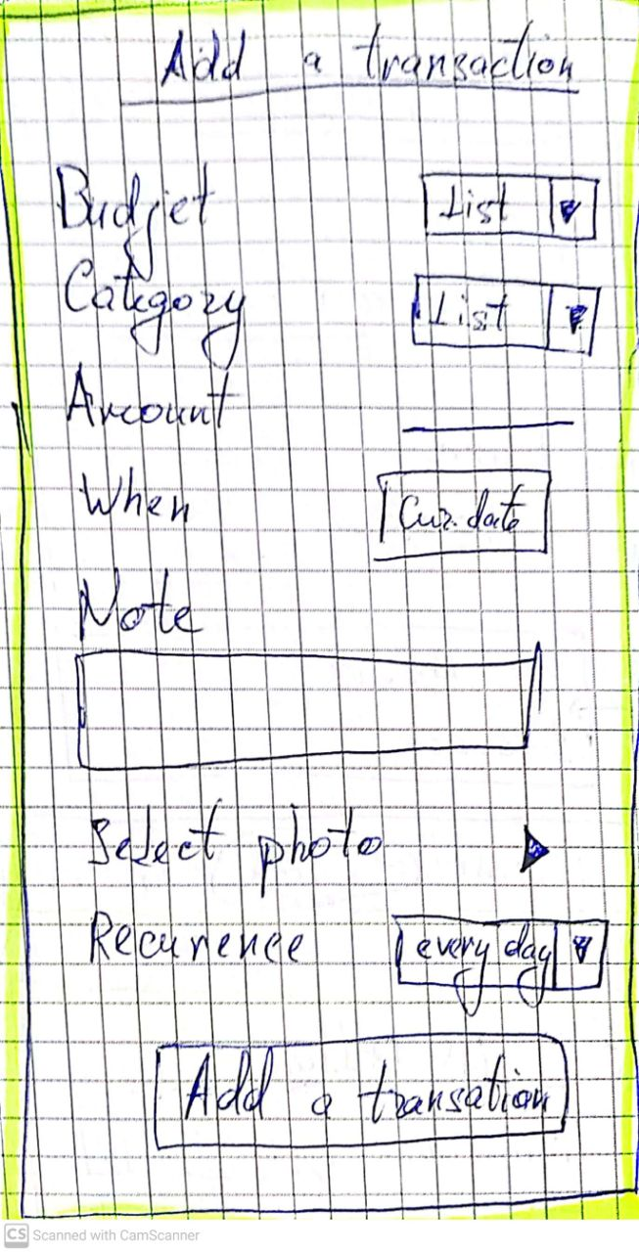 **Transaction creation form**:

1. budget. Selection from the list of those created.
2. Category. Selection from the list of categories assigned when creating the budget
3. Value .
4. Date
5. Note
6. Photo selection
7. Recurrence (creating an automatic transaction at a specified interval)
8. Add Transaction button

When you press the Add Transaction button the transaction is added to the corresponding date at the very top.

Fig. 7. Add new transaction

When you open the application for the first time: Only the budget tab is available.

After user creates at least 1 budget, he has access to History tab where he can create transactions.

After the user archives at least 1 budget, the user has access to the Aryhv tab.